**ASSIGNMENT 5:- BOOTSTRAP**

**Que. 1:- What are the advantages of Bootstrap?**

**Ans.:-**

* Easy to use, even for beginners with basic knowledge of HTML and CSS.
* Responsive features that adjust to phones, tablets, and desktops.
* Mobile-first approach in Bootstrap 3.
* Browser compatibility with all modern browsers.
* Extensive customization options that allow you to personalize the appearance and style of your website.
* Open-source and free, providing a cost-effective solution for web designers.
* Predefined terms that give you the flexibility to make use of these codes instead of creating all the code from scratch.
* Cross-browser functionality ensures your code looks the same on all browsers.
* The UI design of the page does not need to be adjusted.
* Saves time and effort using the Bootstrap predefined design templates and classes.

**Que. 2:- What is a Bootstrap Container, and how does it work?**

**Ans.:-** Bootstrap Containers are the most basic layout element in Bootstrap. Bootstrap Containers are very essential and basic building blocks of bootstrap that wrap a page’s content. It’s responsible for setting and aligning content within it according to viewport or given device. Containers are defined within the container class (.container). In other words, we can say that containers are established with the width for the layout to give the content. Elements and content are added within the container.

Containers are used for many purposes such as :–

* It requires use with the default grid system.
* To establish width for the layout to give web content.
* To provide responsive fixed behavior of any web project.
* To set the content margin dealing with the responsive behavior of your layout.

Bootstrap has the default class or predefined class is “.container” & “.container-fluid” class for layout. Containers are used to contain, pad, and (sometimes) center the content within them. While containers can be nested, most layouts do not require a nested container.

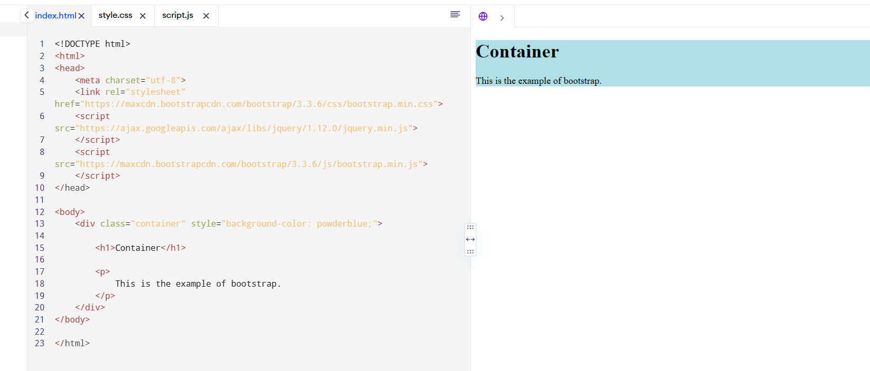

**Que. 3:- What are the default Bootstrap text settings?**

**Ans.:-**

* Bootstrap sets a default font-size of 1rem, 16px by default.
* Bootstrap sets the line-height as 1.5.
* For optimum text rendering on every device and OS through font-family, use the "Native Font Stack".
* The $body-bg variable should be used to set a background-color on the <body> tag, where #fff is by default.
* The global link color can be set using the variable $link-color and apply link underlines only on: hover.
* To apply the typographic base to the <body> tag, use the attributes such as $font-family-base, $font-size-base, and $line-height-base.

**Que. 4:- What do you know about the Bootstrap Grid System?**

**Ans.:-** The Bootstrap grid system has four classes:

* xs (for phones - screens less than 768px wide)
* sm (for tablets - screens equal to or greater than 768px wide)
* md (for small laptops - screens equal to or greater than 992px wide)
* lg (for laptops and desktops - screens equal to or greater than 1200px wide)

The classes above can be combined to create more dynamic and flexible layouts.

**Some Bootstrap grid system rules:**

* Rows must be placed within a .container (fixed-width) or .container-fluid (full-width) for proper alignment and padding
* Use rows to create horizontal groups of columns
* Content should be placed within columns, and only columns may be immediate children of rows
* Predefined classes like .row and .col-sm-4 are available for quickly making grid layouts
* Columns create gutters (gaps between column content) via padding. That padding is offset in rows for the first and last column via negative margin on .rows
* Grid columns are created by specifying the number of 12 available columns you wish to span. For example, three equal columns would use three .col-sm-4
* Column widths are in percentage, so they are always fluid and sized relative to their parent element

**Que. 5:- What is the difference between Bootstrap 4 and Bootstrap 5.**

**Ans.:-**

|  |  |  |
| --- | --- | --- |
| CONTAIN | BOOTSTRAP 4 | BOOTSTRAP 5 |
| Grid System | It has 5 tier (xs, sm, md, lg, xl). | It has 6 tier (xs, sm, md, lg, xl, xxl). |
| Color | It has limited colors. | Extra colors added with the looks, A card improved color palette. there are various shades available to choose. |
| jQuery | It has jQuery and all related plugins. | jQuery is removed and switched to vanilla JS with some working plugins. |
| Internet Explorer | Bootstrap 4 supports both IE 10 and 11. | Bootstrap 5 doesn’t support IE 10 and 11. |
| Offcanvas Component | It does not support Offcanvas Component. | It supports Offcanvas Component (that is it is available now). |
| Bootstrap Icons | Bootstrap 4 doesn’t have its own SVG icons, we must use font-awesome for icons. | Bootstrap 5 have its own SVG icons |
| Vertical Classes | Columns can be positioned relative. | Columns cannot be positioned relative |

**Que. 6:- What is a Button Group, and what is the class for a basic Button Group?**

**Ans.:-**  Bootstrap 5 is the latest major release by Bootstrap in which they have revamped the UI and made various changes. Button group is a component provided by Bootstrap 5 which helps to combine the buttons in a series in a single line. All types of buttons are supported by it.

***Syntax:-***

<div class="btn-group"> Buttons... <div>

Types: Following are the nine types of buttons available in Bootstrap 5:

* btn-primary
* btn-secondary
* btn-success
* btn-danger
* btn-warning
* btn-info
* btn-light
* btn-dark
* btn-link

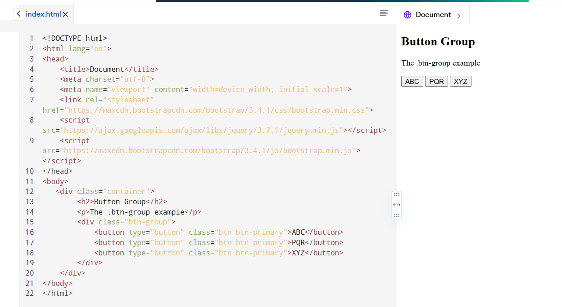

**Que. 7:- How can you use Bootstrap to make thumbnails?**

**Ans.:-** Bootstrap helps web developers to create thumbnails that are used to show linked images in grids with the pre-defined classes which help to reduce codes length. Thumbnails are created to provide a quick preview of images with small images.

Thumbnail Image: A thumbnail is a small image that represents a larger image. Bootstrap has an easy way to do this with thumbnails. Bootstrap’s .thumbnail class is used to show linked images in grids (grid system), a thumbnail is created using class .thumbnail within the element <a>. The class .col-sm-* and .col-md-* (where * represent number), it is used to create grids of the images.

Step 1: Include Bootstrap and jQuery CDN into the <head> tag before all other stylesheets to load our CSS

Step 2: Add <div> tag in the HTML body with class row. In that <div> create four div sections to create four images.

Step 3: Add “col-sm-6” and “col-md-3” to four div sections which creates webpage responsive.

Step 4: Add <a> tag with class value thumbnail to define the link of the image in the next line.

***Syntax:-***

<a href="#" class="thumbnail">

**Que. 8:- In Bootstrap 4, what is flexbox?**

**Ans.:-** The biggest difference between Bootstrap 3 and Bootstrap 4 is that Bootstrap 4 now uses flexbox, instead of floats, to handle the layout.

The Flexible Box Layout Module makes it easier to design flexible responsive layout structure without using float or positioning. If you are new to flex, you can read about it in our CSS Flexbox Tutorial**.**

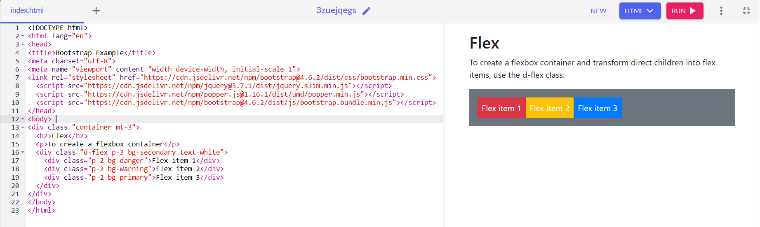

**Que. 9:- How can one create an alert in Bootstrap?**

**Ans.:-** Alerts are created with the .alert class, followed by one of the four contextual classes .alert-success, .alert-info, .alert-warning or .alert-danger

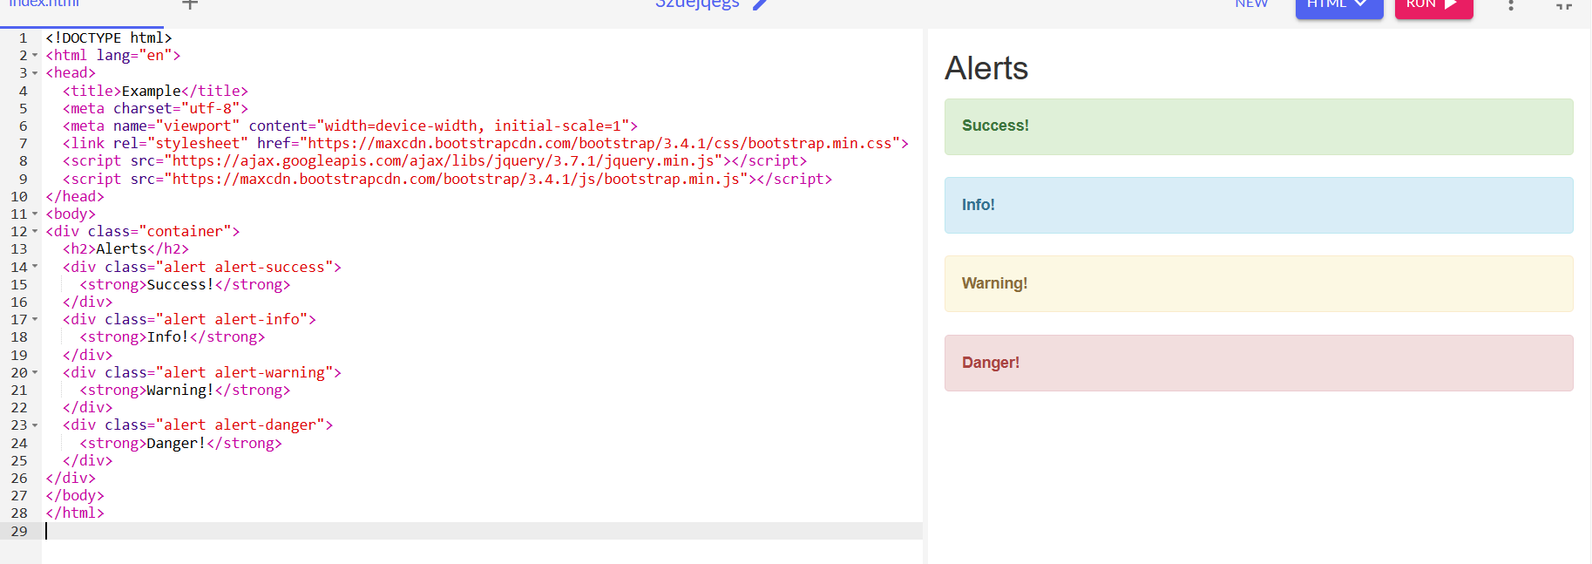

**Que. 10:- What is a bootstrap card and how would you create one?**

**Ans.:-** A card is a flexible and extensible content container. It includes options for headers and footers, a wide variety of content, contextual background colors, and powerful display options.

It replaces the use of panels, wells and thumbnails. All of it can be used in a single container called card.

* .card-img-top places an image to the top of the card. With .card-text, text can be added to the card. Text within .card-text can also be styled with the standard HTML tags.
* Card titles are used by adding .card-title to a <h*> tag. In the same way, links are added and placed next to each other by adding .card-link to an <a> tag.
* Subtitles are used by adding a .card-subtitle to a <h*> tag. If the .card-title and the .card-subtitle items are placed in a .card-body item, the card title and subtitle are aligned nicely.

